**React Index: Things that confused me**

A collection of gotchas, react-specific who-what, and so-forth.

**Sometimes you’ll see a function or component in React that has parenthesised arguments. Why?**

This is object destructuring!

‘props’ are objects in React. Have a look at the example below, which is an object with 3 properties:



If we expect those three arguments in our object, we can *destructure* it in our function declaration in order to directly refer to them by name:

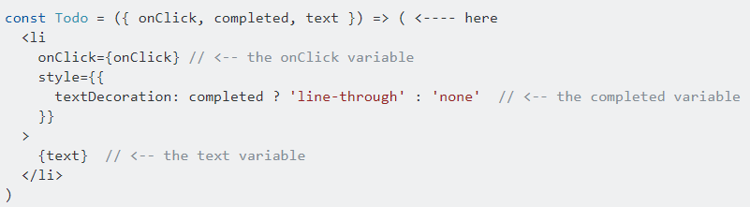

If we just take the object as ‘props’ we’ll need to unpack the properties within that object as we go, using the traditional ‘object.property’ syntax:

